Turbidity Calibration Tutorial

# set up

In order to calibrate your turbidity sensor, you’ll need:

* Electronics
  + Feather M0 LoRa Radio
  + Breakout board for Feather
  + MicroUSB cable
  + Uncalibrated, waterproofed turbidity sensors
* Permanent marker and tape for labeling
* Supplies for making dark box
  + Black foam board
  + Tape or hot glue
  + Pen that writes on black
  + Foam tape
* Supplies for making standards
  + Lots of identical, tiny, glass jars
  + Formazin
  + Distilled water
  + 10 mL, 1mL pipettes
  + 100 mL volumetric flask
  + Enough graduated cylinders for all the standards
  + Cutting oil
  + Larger containters
  + Tissues

# Making formazin standards

1. 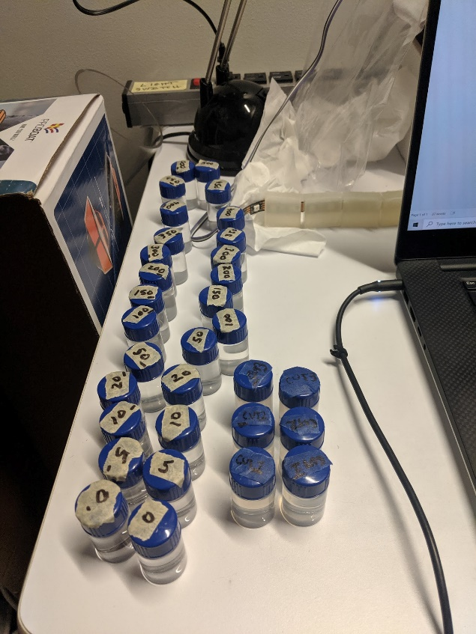Download information booklet: <https://sea.hach.com/formazin-turbidity-standard-4000-ntu-500-ml/product-downloads?id=26514554120>.
2. Navigate to “Appendix II. Preparing Formazin Dilutions,” on page 13.
3. We made dilutions ranging from 0-500 NTU, incrementing by 50 NTU.
   1. Make sure all the tiny vials are the same.
   2. Make a total of ***two*** vials for each data point in order to average data later on.
      1. Swirl the standard solution before splitting between the two vials.
      2. Distinguish between the solutions somehow; we added a dash to one vial in each pair.
   3. Make sure to label each vial with the correct number of NTUs.
4. Wipe down all the vials with tissues so that there is nothing that might disrupt the sensor readings.

# Making dark box

1. 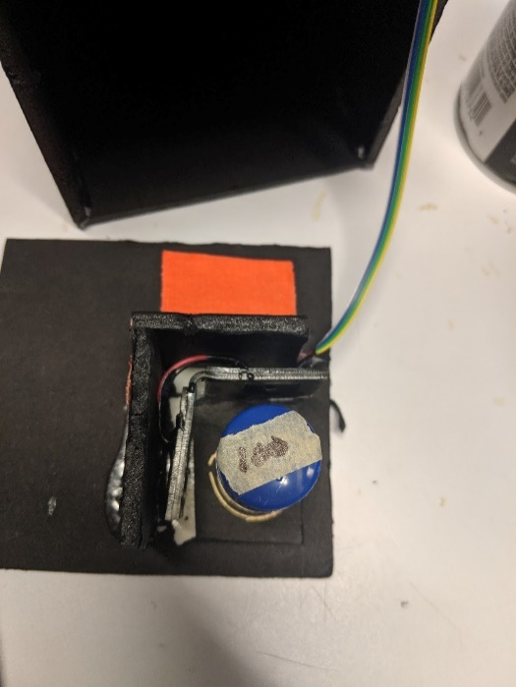 Cut out from the foam board: a platform, a 90°-angled notch for sensor, walls for the box, and a cover/top.
   1. Make sure to leave room for wires.
2. Use tape or hot glue to connect the walls and top together, and the notch and platform together.
3. Put one sensor in, and figure out where intersection of sensor/LED paths are. Place a vial there and draw a circle around the vial.

# measuring and recording data

1. Design the spreadsheet for collecting the data.
   1. The labels are: sensor, standard.NTU, test.type, sample.label, media, ave.freq.kHz, irradiance.mW.cm2.

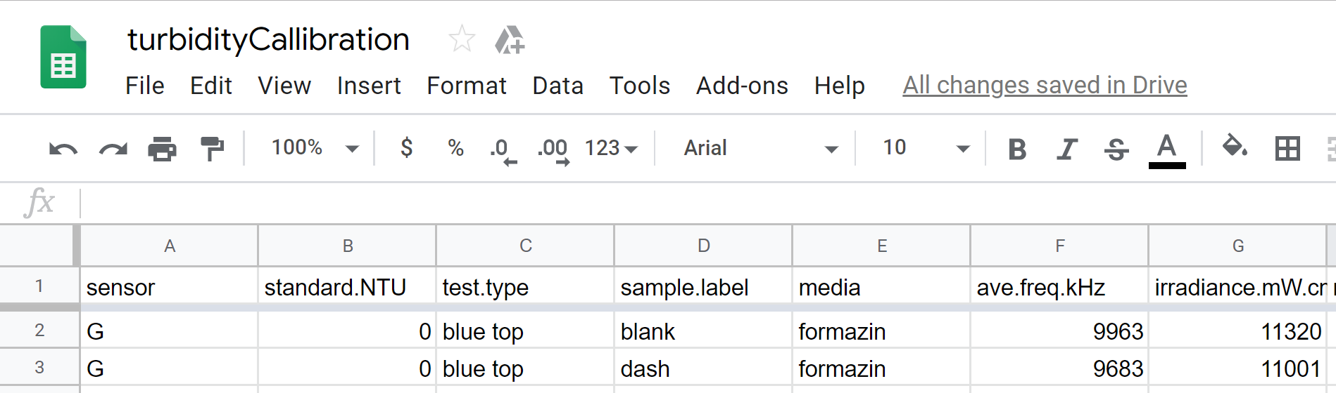

1. Use the turbidity code on GitHub: "GitHub\seeboat\software\testing\turbidity\turbidity.ino."
2. Turn off all the lights in the room, and make sure there are no weird shadows over the box.
3. 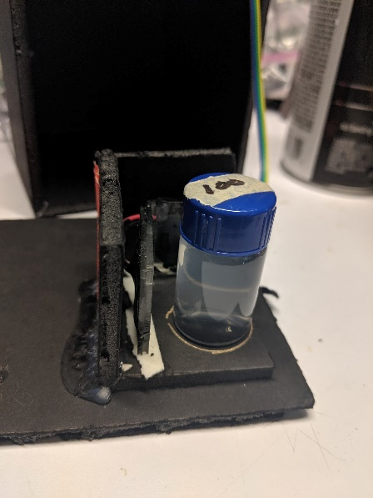Measure ave.freq.kHz and irradiance.mW.cm2 for each vial, moving from low to high. Mark the values in the spreadsheet. Don’t move the sensor during calibration; change the vial not the sensor.
   1. Make sure the vial is centered.
   2. Make sure mixture is distributed (invert and swirl if not).
   3. Make sure there are no fingerprints on the vial.
   4. Stick down the sensor securely.
   5. Check that the center of the vial is still correct between sensors.
   6. Make sure the box is sufficiently blocking light.
   7. Let the data stabilize before recording values.

# cutting oil secondary standards

1. Based on the first sensor’s data, try to hit roughly the same range of cloudiness as the data.
2. 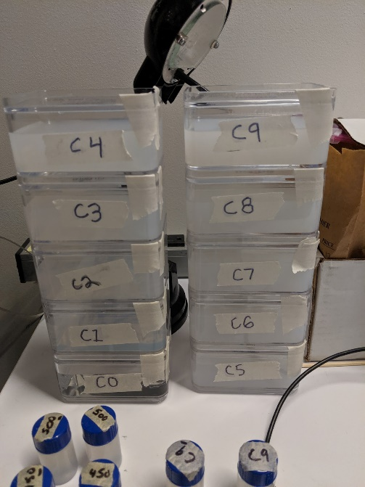Continue to dilute the mixture, and continue to measure the value with the sensor to see how close you are to the minimum, or maximum of the data endpoints.
3. 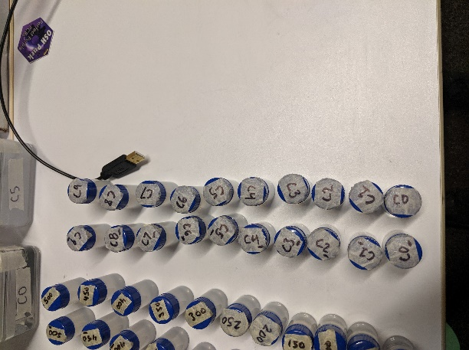Make a full larger container of each data point large enough to fully submerge sensor in, and two small vials per data point.
4. Label CUT1, CUT2…
5. Measure the small vials of cutting oil with the first sensor still in place, and record in the spreadsheet.
6. Reference: <https://www.mdpi.com/1424-8220/14/4/7142>.

## record data for each sensor!

# Data analysis

1. Make an xy scatter plot for each sensor.
2. Fit a regression curve for all the formazin data points.
3. Add the cutting oil data points, back-calculate the NTU for cutting oil standards.
   1. Should now have NTU values for CUT1, CUT2…
4. See how consistent sensors are with cutting oil NTUs.
5. Compute percent differences between the two vials in each pair, see if there are consistencies across sensors.
6. Check if any data looks weird overall.
7. Identify sensors’ precision within certain ranges.
8. Discard sensors based on bad fit, weird regression lines, etc.

# Calibrate for free water use

1. Submerge each sensor in cutting oil large containers.
2. Wrap the container with black paper to block light.
3. Record ave.freq.kHz and irradiance.mW.cm2 in the spreadsheet.
4. Repeat steps 1-3 for each sensor to get two data points.
5. Wipe down the sensor to remove oil.
6. Calculate for each sensor the equation to get free water NTU based on Arduino readings.